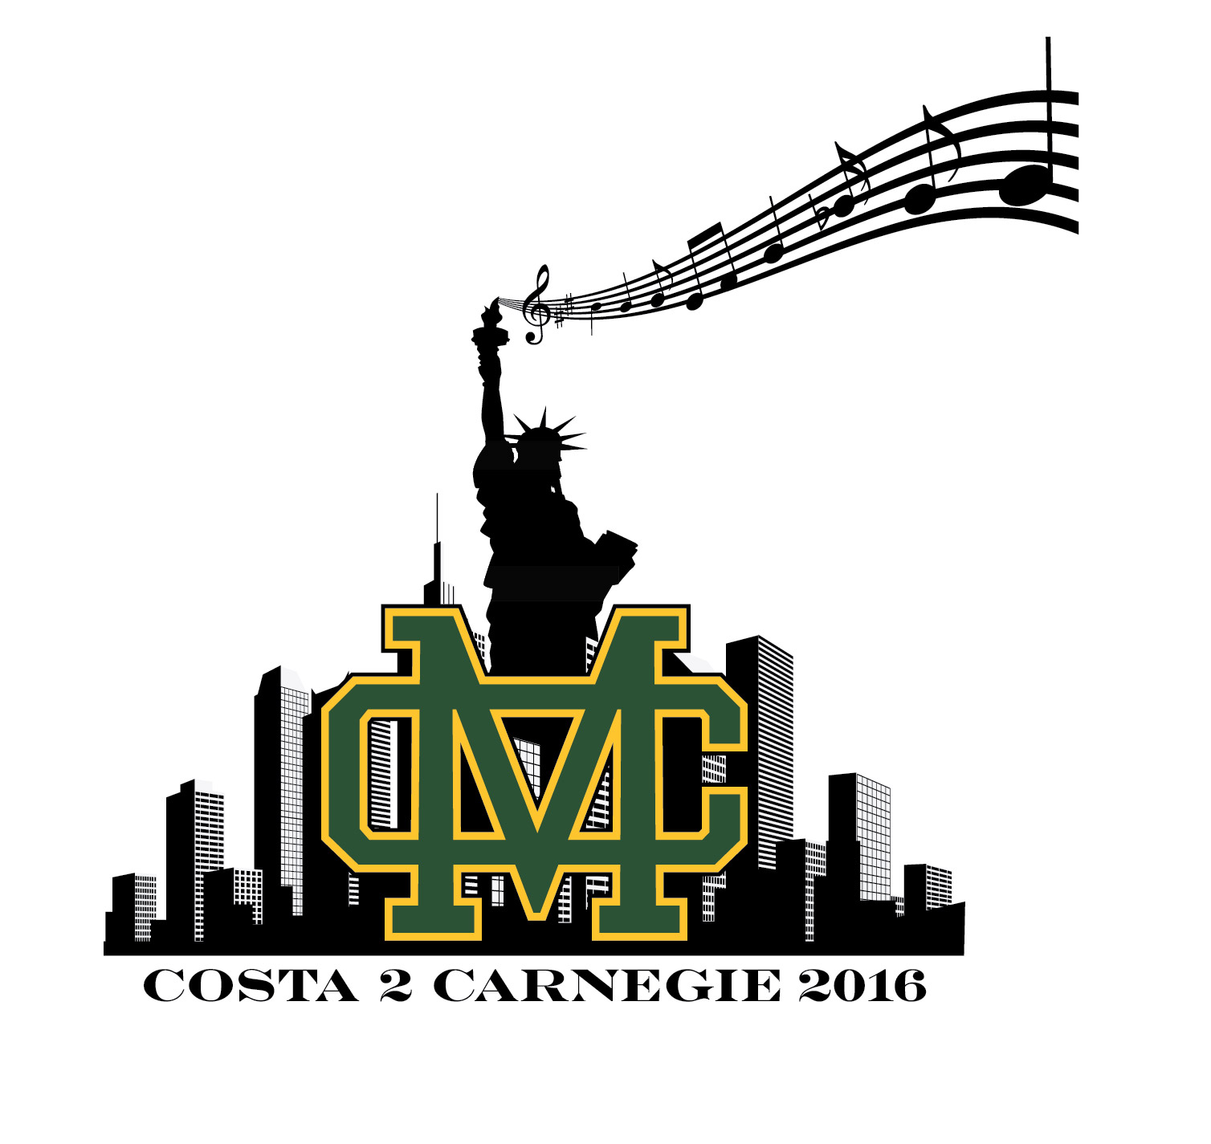

Dear Education and Performing Arts Supporter;

Our 2014 Grammy Award winning Mira Costa High School Bands and Orchestra Programs provide almost 300 students an environment to grow and develop artistically, intellectually and emotionally. This approach to arts education produces great music and confident, collaborative, creative and academically successful students with valuable skills that extend beyond their performing arts programs.

These outstanding organizations have been honored with an invitation to perform at world famous Carnegie Hall in New York City for 1500 patrons as part of the Distinguished Concerts International New York Series.

Traveling with three band ensembles and two orchestras to New York’s Carnegie Hall is not small task. That is over 300 headed to the Big Apple! Students are practicing; parents are organizing and fundraising, but travel for a group this size is costly and a complex logistical operation. For example, basic costs like luggage fees will cost us at least $7500 at $25 person or $6000 for a one modest lunch for the group. In addition and most importantly we need to provide financial assistance to some students who want to join their peers in this incredible opportunity, but are unable to fully afford the trip.

We are asking generous corporate sponsors and vendor partners like you for your support so these talented young musicians can go to New York and represent the South Bay.

The following page lists Sponsorship Tiers available and the benefits we are able to offer. All contributions are tax deductible.

We are excited to have you join our journey from costa2carnegie! Many thanks in advance for your support and well wishes.

Kind Regards,

Danielle Anderson
VP Fundraising, Mira Costa High School Bands
Manhattan Beach, CA
Danielle.anderson96@gmail.com
310.487.3059

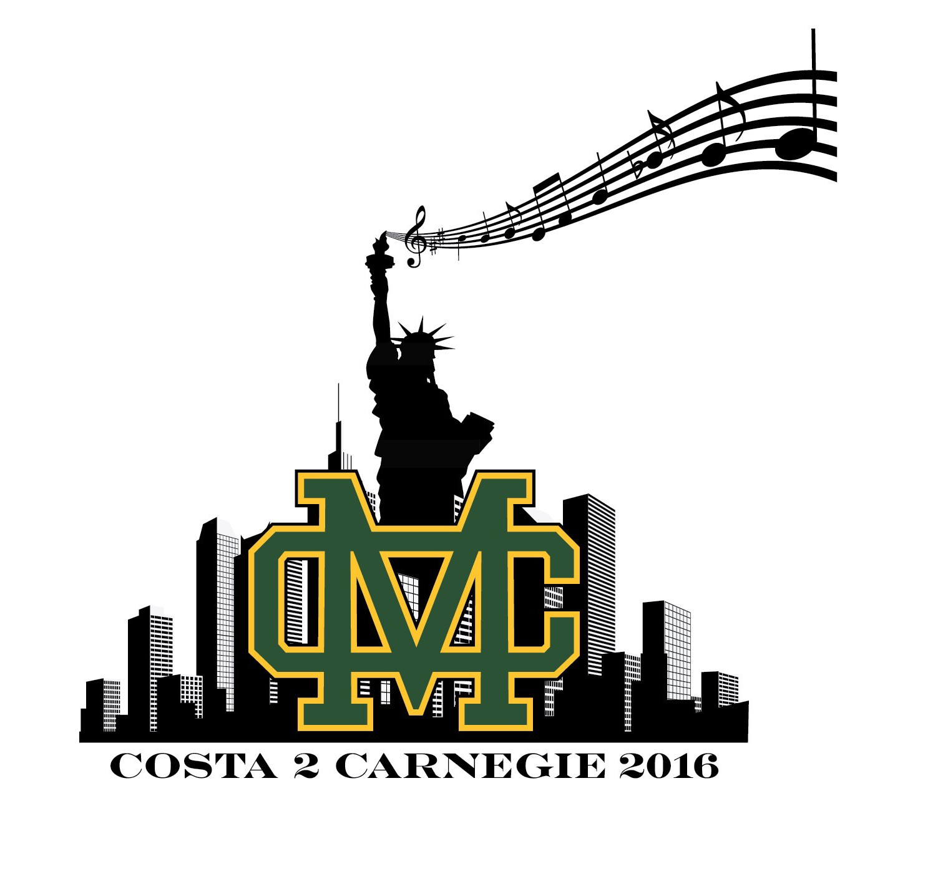
Corporate Sponsorship Opportunities |  | Director  $20,000 |  | Sponsor  $10,000 |  | Partner  $5,000 |  | Advocate  $3,000 |  | Associate  $1,500 |  | Affiliate  $500
Acknowledgement on Social Media Outlets |  | x |  | x |  | x |  | x |  | x |  | x
The Beach Reporter Acknowledgement  May, 2016 |  | Prominent logo |  | Prominent logo |  | Co. Name in bold |  | Listed |  | Listed |  | Listed
Concert Tickets/concert at Maestro Circle Seats |  | 4 |  | 4 |  | 2 |  | 2 |  | 2 |  | 2
Acknowledgement in printed performance program |  | Full Back Outside (color) |  | Full page inside back or front inside cover (B/W) |  | half |  | quarter |  | business card
Clickable Logo on band, orchestra websites |  | x |  | x |  | x |  | x |  | x
Logo projection at performances |  | x |  | x |  | x |  | shared |  | shared |  | shared
Logo on 600+ Carnegie Hall participant t-shirts |  | x |  | x |  | x |  | x
VIP on stage recognition at Send-off Concert on May 24, 2016 |  | x |  | x |  | x |  | x
Solo banner at MCHS Waller Stadium displayed for 1 year |  | x

Please mail this completed form and check payable to MBx Foundation to: Carnegie Fund c/o MBx Foundation, PO Box 1585, Manhattan Beach, CA 90267-1585

Business Name:

Complete Address:

Contact Name:

Phone #:

Email Address:

Select Sponsorship Level
 | Director | $20,000
 | Sponsor | $10,000
 | Partner | $5,000
 | Advocate | $3,000
 | Associate | $1,500
 | Affiliate | $500
Thank you for your valuable support!

